

Year 7 Science: Forces Test

Date:

Writing time: 55 minutes

Student Name:
_________________________________________________________________________

Teacher: ESC FRO LSE MAX

Total | /50
Total %

Materials supplied
- Students are permitted to use pens, pencils, highlighters, erasers, sharpeners, rulers, one scientific calculator.
- Question and answer book
- Data and Formula sheet
Instructions.
- Write your name in the space provided above on this page
- Circle or highlight your teacher’s code.
- All written responses must be in English.

Question 1
Forces are measured in
- Celsius
- Metres
- Newtons
- Neutrons
Question 2.
Which of the following is not a type of force?
- Friction
- Gravity
- Normal
- Chemical
Question 3.
Which of the following statements is true about forces?
- They can only be pushes
- They have direction and size
- Only one force can act on an object at a time
- Forces must be touching to affect an object
Question 4.
Which of the following pairs only includes contact forces?
- Normal and Friction force
- Electrostatic and Applied force
- Gravity and Tension force
- Spring and Magnetic force
Question 5.
Which of the following is true about Gravity on Earth?
- It’s a pushing force
- It affects all objects
- It only acts on objects close to its surface
- It only acts on objects above the surface pulling them down

Consider the image below of a man pushing a trolley in a normal supermarket at a constant speed for questions 6, 7 and 8.


Question 6.
Consider the force on the trolley by the person to push forward what is the opposite force in this force pair?
- The force on the wheels by the floor
- The force on the person by the trolley
- The force on the ground by the trolley
- The force on the trolley by the Earth
Question 7.
Consider the force on the trolley by the Earth’s gravity pulling it towards the ground what is the opposite force in this force pair?
- The force on the trolley by the man
- The force on the trolly by the floor
- The force on the floor by the trolley
- The force on the Earth by the trolley
Question 8.
Which of the following is true regarding the forces acting on the trolley?
- The man applies more force to the trolley than the trolley does to him
- There must be no friction on the floor for the trolly to move
- The forces acting on it are balanced
- The trolley will continue to move at constant speed if the man stops pushing

Question 1.
a. Explain what forces are.
_________________________________________________________________________________
_________________________________________________________________________________
(2 marks)
b. Complete the table below summarizing different types of force.
Name of force | Definition / description | Contact or non-contact
Friction
 | A pulling force that occurs between any two objects that have mass.
 | A force from a fluid (liquid or gas) that pushes up on an object that is floating on top of it.
Normal
Electrostatic
(5 marks)
Question 2.
Consider the forces acting on the underlined object in the situation below. Draw arrows on the diagram to show the forces you identified in the question above. Label these arrows with the name of the forces (eg F _{friction}). Remember your arrow length should indicate the size of the forces.
Situation 1: A Person sitting motionless on a chair.


Situation 2: A strong magnet attached to a clamp on a retort stand attracts a paper clip tied to the base by a piece of string.
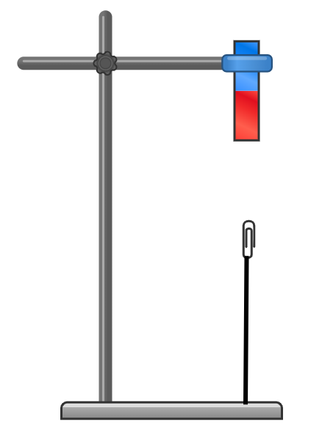

(2 + 3 marks, 5 marks)
Question 3.
Motion refers to the movement of an object. Forces can affect the motion of an object.
a. Name two different effects that forces can have on the motion of an object.
_________________________________________________________________________________
_________________________________________________________________________________
(2 marks)
b. Define the term net force.
_________________________________________________________________________________
_________________________________________________________________________________
(1 mark)
c. The diagrams below show forces acting on different objects. For each of the following diagrams, label whether the forces are balanced and unbalanced and write the net force acting on the object.
Force diagram | Forces balanced  or unbalanced? | Net force (N)
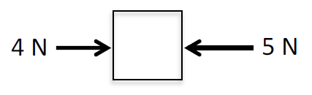
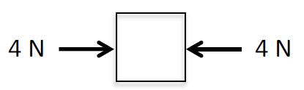
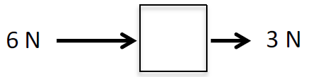
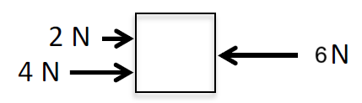
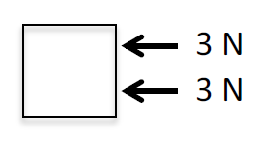
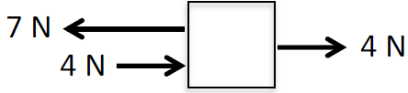
(6 marks)
Question 4.
a. For each situation, draw a force diagram of the forces acting on the soccer ball object. Use arrows to show the forces acting on the object. Label the forces (eg F _{gravity}). Remember your arrow length should indicate the size of the forces.
Situation 1: A soccer ball on the ground is kicked by a player
(the moment the foot connects with the ball).

(3 marks)
Situation 2: A soccer ball moves upwards into the air after being kicked.

(3 marks)

Situation 3: A soccer ball slows down as it rolls across grass.

(3 marks)
b. Describe the direction of the net force in each of the situations. What does this suggest about the motion of the soccer ball in each situation.
Situation 1:
_________________________________________________________________________________
_________________________________________________________________________________
_________________________________________________________________________________
Situation 2:
_________________________________________________________________________________
_________________________________________________________________________________
_________________________________________________________________________________
Situation 3:
_________________________________________________________________________________
_________________________________________________________________________________
_________________________________________________________________________________
(3 marks)

Question 5.
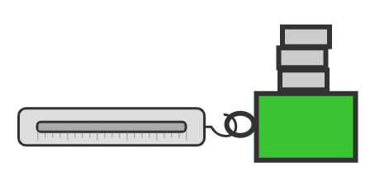
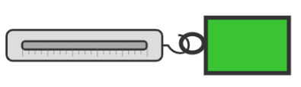
Students investigate how friction forces change as you add mass. They conducted an experiment by attaching a spring balance to a wooden block and then dragging the block at a constant speed and recording the force required to pull the block. They then repeat this and add more masses on top of the block. The class then averaged their results graphed them as shown below.
a. Estimate the friction force exerted on a block with 300g of mass on it.
_________________________________________________________________________________
(1 mark)
b. Based on the student’s results explain how mass affects the friction force measured.
_________________________________________________________________________________
_________________________________________________________________________________
(1 mark)
c. List and explain something else that affects the friction force exerted on an object.
_________________________________________________________________________________
_________________________________________________________________________________
_________________________________________________________________________________
(2 mark)

Question 6.
Objects on Earth experience the pulling force of its gravity. Because of gravity objects exert a weight force downwards. This force can be calculated using the Formula $F=m×g$ where F is the gravitation force (N), m is the mass (kg) and g is the strength of the gravity (9.8 m/s/s on Earth).
a. Calculate the weight force of a 45 Kg student exerts downwards onto their chair as they complete a science test. Show all calculations.

(1 mark)
b. Imagine the student travelled to the moon where g = 1.6 m/s/s. What is the mass of the student on the moon?

(1 mark)
c. What is the weight force of the student on the moon? Show all calculations.

(1 mark)
d. List and explain a factor that affects the size of the gravitational force exerted by an object.
_________________________________________________________________________________
_________________________________________________________________________________
_________________________________________________________________________________
_________________________________________________________________________________
(2 marks)
Criterion | 6.0 | 6.5 | 7.0 | 7.5 | 8.0
The nature of forces | I can identify pushes and pulls. | I can define forces as pushes or pulls | I can define forces as pushes or pulls between objects. | I can identify forces acting in pairs in specific circumstances. | I can represent the forces acting in pairs considering the direction and size.
Types of forces | I can identify pushes and pulls. | I can list different forces. | I can define and identify different types of forces in specific circumstances. | I can describe different forces and can categorise them as contact or non-contact forces. | I can explain how different factors affect specific types of forces (eg. Friction, Gravity).
Balanced, unbalanced and Net forces | I can identify when multiple pushes and pulls are occurring at once. | I can identify when there are more forces acting in one direction. | I can identify when forces are balanced and unbalanced. | I can calculate and describe the net force acting on an object. | I can represent the net forces acting on and object consistent with its motion.
Forces and motion | I can describe the motion of an object. | I can describe how forces may affect the motion of an object. | I can describe how balanced and unbalanced forces affect the motion of an object. | I can interpret how a net force acting on an object can influence its motion. | I can explain how changes in the net forces acting on an object affect its motion.

